| ***REST - Get country based on country code*** |
| --- |

In our “country.xml” we add a new bean of “java.util.ArrayList” class that will contain “constructor-arg” as “list” of beans of many “Country” beans. Spring processes these as part of the application context. When these objects are returned from a REST controller, Spring Boot (via Jackson) automatically serializes them into JSON responses.

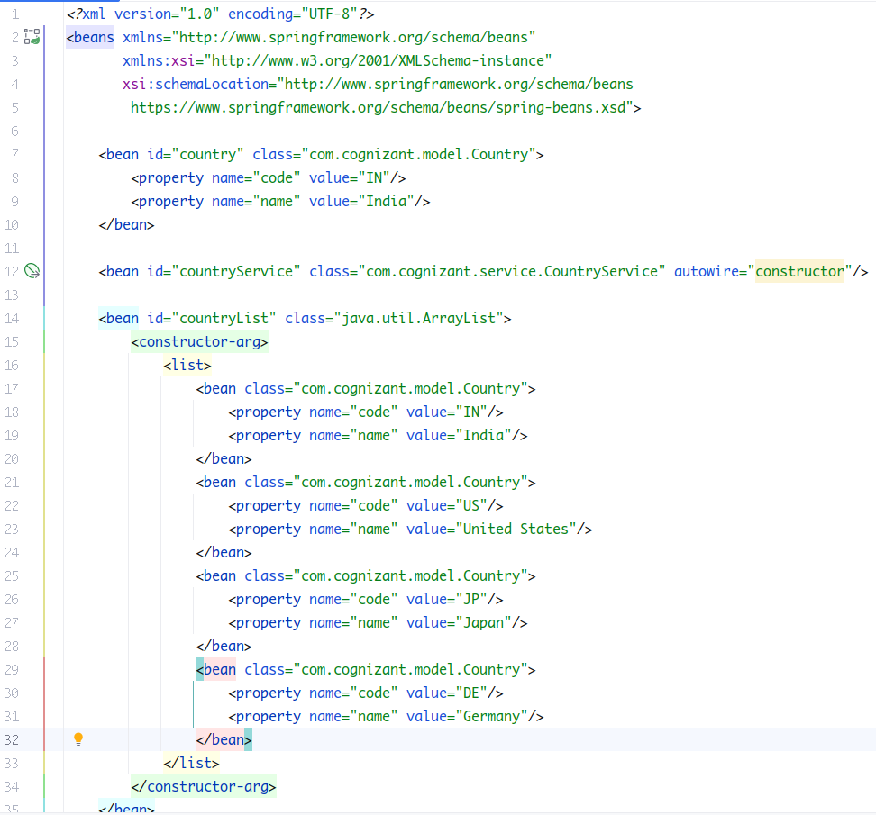

Inside the controller package, add a new mapping method, to test if the api gives out all the countries at a specified mapping, (say “/countries”).

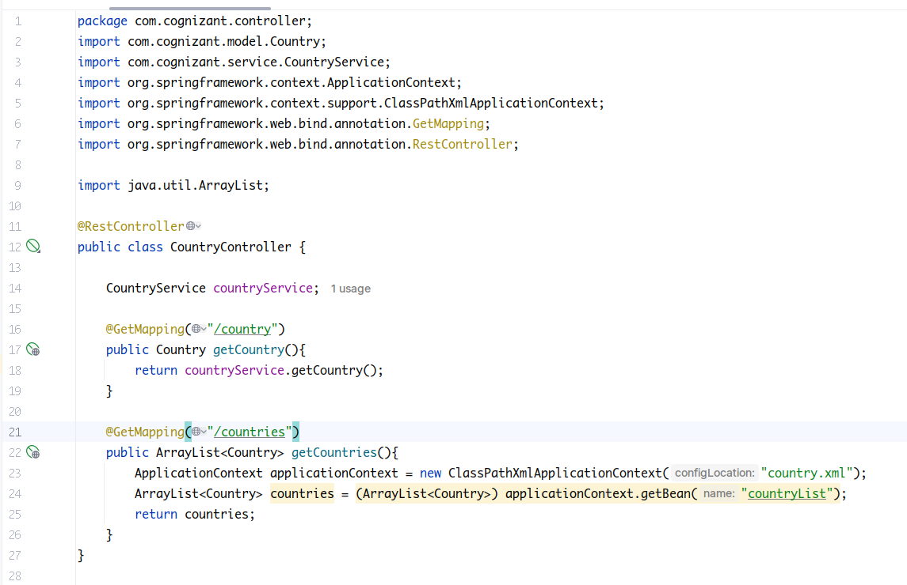

And yes it does.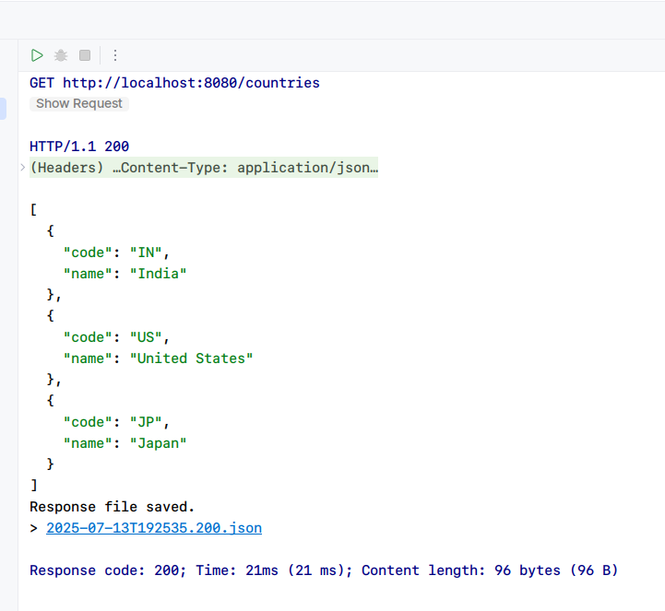

Now lets implement method to set a single country by “code” inside our service class. We will now use full Spring boot for configuration as it is easy to work with.

We add mapping, methods and reqd xml configs for the api endpoint.

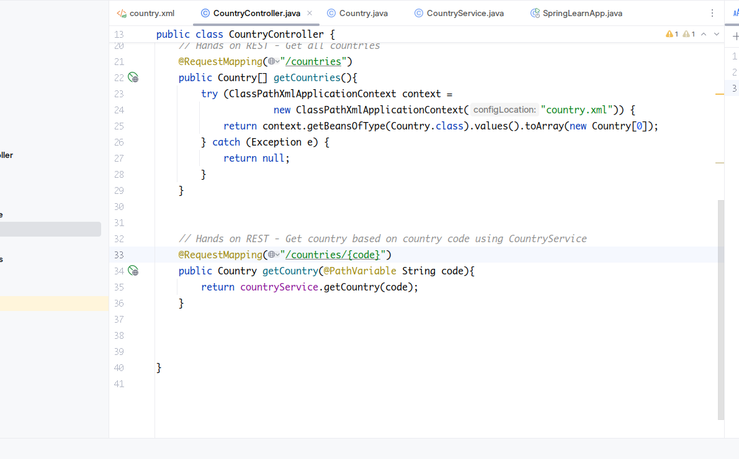

*<!--Spring REST Hands on 4 Country Bean-->*

<beans xmlns="http://www.springframework.org/schema/beans"

xmlns:xsi="http://www.w3.org/2001/XMLSchema-instance"

xsi:schemaLocation="http://www.springframework.org/schema/beans http://www.springframework.org/schema/beans/spring-beans.xsd">

<bean id="countryList" class="java.util.ArrayList">

<constructor-arg>

<list>

<bean class="com.cognizant.model.Country">

<property name="code" value="IN"/>

<property name="name" value="India"/>

</bean>

<bean class="com.cognizant.model.Country">

<property name="code" value="US"/>

<property name="name" value="United States"/>

</bean>

<bean class="com.cognizant.model.Country">

<property name="code" value="DE"/>

<property name="name" value="Germany"/>

</bean>

<bean class="com.cognizant.model.Country">

<property name="code" value="JP"/>

<property name="name" value="Japan"/>

</bean>

</list>

</constructor-arg>

</bean>

<bean id="in" class="com.cognizant.model.Country">

<property name="code" value="IN"/>

<property name="name" value="India"/>

</bean>

<bean id="us" class="com.cognizant.model.Country">

<property name="code" value="US"/>

<property name="name" value="United States"/>

</bean>

<bean id="de" class="com.cognizant.model.Country">

<property name="code" value="DE"/>

<property name="name" value="Germany"/>

</bean>

<bean id="jp" class="com.cognizant.model.Country">

<property name="code" value="JP"/>

<property name="name" value="Japan"/>

</bean>

</beans>

